Samurai, Yokohama
Felice Beato | ca. 1864–65 | Record IMG-EA0003

1. Original Image
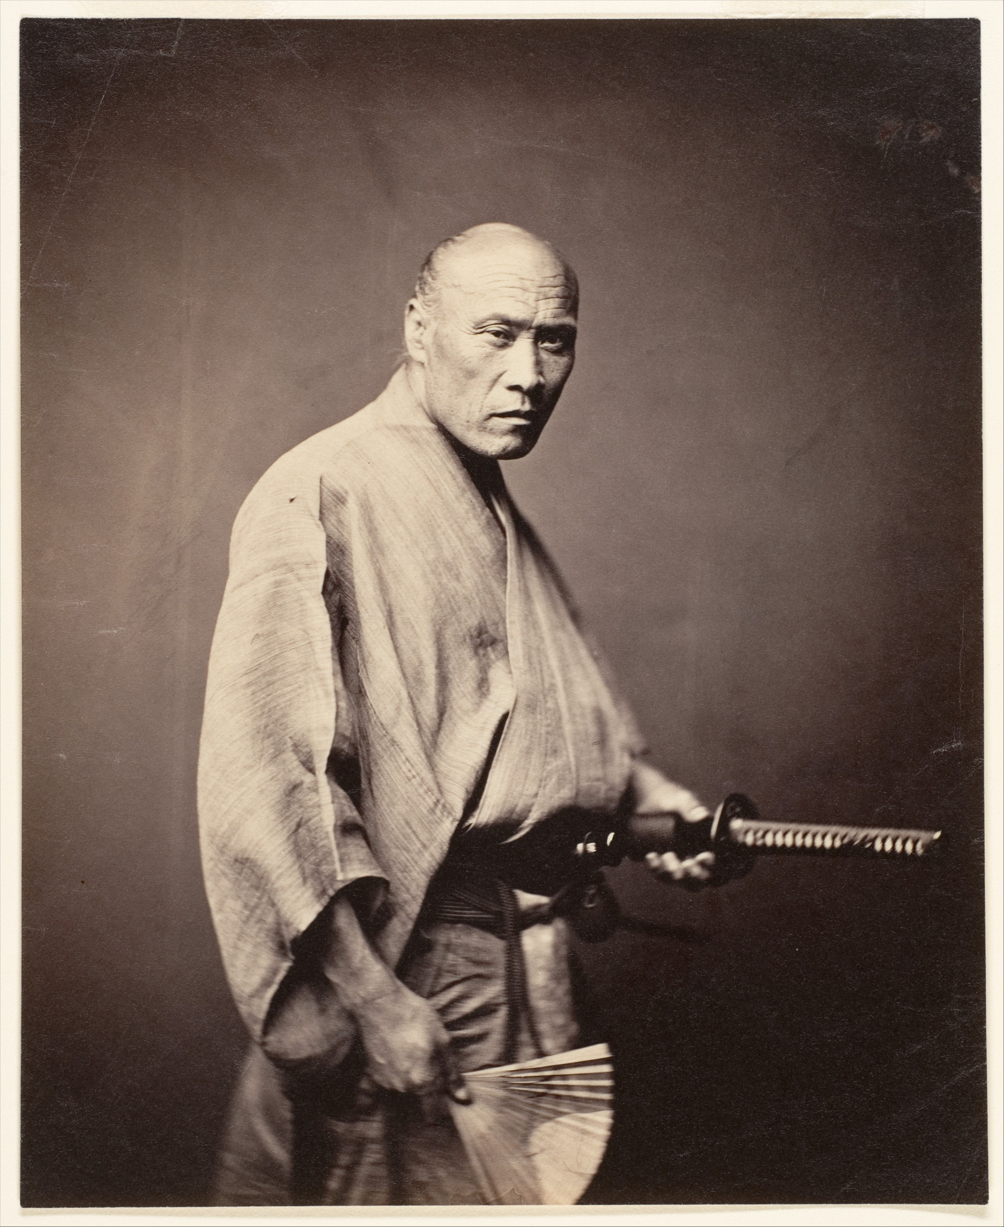
IMG-EA0003. Felice Beato, Samurai, Yokohama, Shanghai River, ca. 1864–65, Albumen silver print from glass negative. The Metropolitan Museum of Art.

2. Record Summary
Record ID | IMG-EA0003
Original title | Samurai, Yokohama
English title | Samurai, Yokohama
Alternative title | N/A
Creator | Felice Beato
Creation date | ca. 1864–65
Country | Japan
Cultural region | East Asia; Yokohama
Historical period | Late Edo period; early studio photography in Japan
Image type | Photography
Medium | Albumen silver print from glass negative
Dimensions | 17.9 × 14.6 cm
Primary subject | Standing adult man holding a sword
Secondary subjects | Robe, sash, folded fan and studio backdrop
Source institution | The Metropolitan Museum of Art
Collection or object number (optional) | 2005.100.566

3. Image Description

3.1 Short Description
A full-length studio portrait shows one adult man standing against a plain dark backdrop. He wears a light robe secured with a dark sash and holds a sheathed sword horizontally at waist height. A folded fan is visible near his lower body, and the figure turns slightly while looking toward the camera.

3.2 Detailed Visual Description
The man occupies nearly the full height of the vertical photograph. His torso is angled slightly toward the viewer’s right, while his head turns forward. His hair is arranged close to the head, though the exact hairstyle is difficult to describe at this scale. A loose, light-coloured robe wraps across his chest and falls toward his ankles. A wide dark sash surrounds his waist.
His right hand rests near the handle of a long sheathed sword extending horizontally toward the right edge. His other hand appears to touch or hold a folded fan. His feet are partly concealed by the robe and lower edge of the print. The background is plain and dark, with a subtle tonal gradient behind his head and shoulders. Frontal light defines the garment folds and facial contours. No furniture, architecture, additional people or written text are visible.

4. Formal Features
Field | Analysis
Composition | The standing figure is centred and isolated; the sword creates a strong horizontal line.
Viewpoint or camera angle | Approximately torso height, facing the sitter directly.
Shot scale | Full-length portrait.
Spatial depth | Shallow studio space.
Lighting | Directional studio lighting models the face, robe and sword.
Colour palette | Warm monochrome brown, cream and dark grey.
Contrast | The pale robe contrasts with the dark backdrop and sash.
Visual focus | Face and sword handle.
Texture | Soft cloth contrasts with the rigid surfaces of the sword and fan.
Movement or stillness | The pose is controlled and stationary.
Medium-specific features | Fine glass-negative detail is visible in the clothing and facial features.

5. Historical Context and Purpose

5.1 Historical Context
Beato lived and worked in Japan from the early 1860s and produced both location photographs and studio portraits for an international market centred partly in Yokohama. The Met dates this print to 1864–65 and identifies the sitter through the historical title as a samurai. It was made shortly before the Meiji Restoration and the eventual abolition of the samurai class. The Museum also notes that the portrait predates the 1866 fire that destroyed much of Beato’s Yokohama studio and archive. [IMG-EA0003-S01] Image Purpose and Circulation

5.2 Image Purpose and Circulation
Original purpose: Not verified.
Probable purpose: Commercial studio portrait intended to circulate as an image of a Japanese social or occupational type.
Current institutional use: Historical interpretation of nineteenth-century photography in Japan.

